BuyHaven – E-Commerce
Website/management sysytem

Submitted By:
Name: Shashwath Singh
SAP ID: 590017043
Name: Harsh Chauhan
SAP ID: 590016645
Submitted to : Kalluri shareef babu
College: UPES, Dehradun
Course: B.Tech CSE
Semester: 3rd Semester

1. Introduction

In today’s digital era, online shopping has become a fundamental part of our daily lifestyle. People prefer buying products through e-commerce websites because of convenience, wide product variety, secure payments, and doorstep delivery. To understand and implement the core working of an e-commerce system, I developed a fully functional online store named BuyHaven.

This project demonstrates how an e-commerce platform is created using Flask (Python Web Framework) as the backend and MySQL as the database. The application also supports essential e-commerce features such as product listing, category-wise filtering, shopping cart management, and quantity control.

2. Objectives of the Project

The primary objectives of this project are:

To design and develop a fully functional online shopping website.

To implement product management using a relational database (MySQL).

To enable users to browse products by categories and add them to the cart.

To implement CRUD-based cart operations including View Cart, Add, Update Quantity, and Remove Items.

To provide a user-friendly interface and smooth navigation experience.

3. Technologies Used
Component Technology
Frontend HTML, CSS, JavaScript
Backend Python (Flask Framework)
Database MySQL (command line)
Server Environment Flask Development Server
Temporary Hosting : Ngrok

4. System Architecture

The project follows a standard Client–Server Architecture:

The user interacts with the interface (browser).

Flask receives the request and processes it.

MySQL stores and retrieves relevant product and user data.

The results are displayed dynamically on the webpage.

5. Features Implemented

- Category-based product filtering (Mobiles, Laptops, Cosmetics, Self Care, Clothing, etc.)
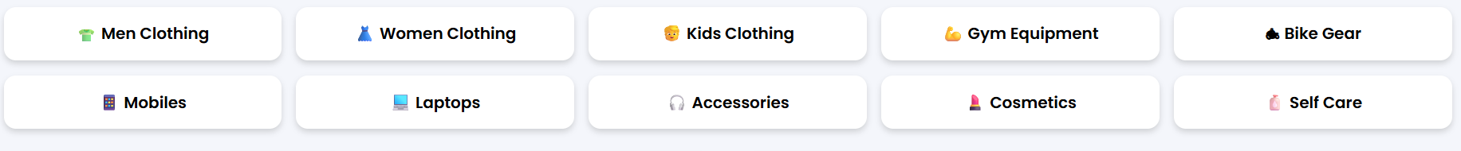
- Add to Cart functionality

- Update product quantity in cart and Remove items from cart

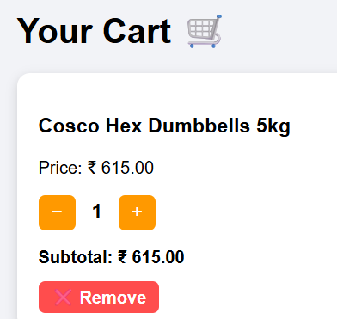
4. Flash messages for user actions
5. Responsive and visually appealing UIt
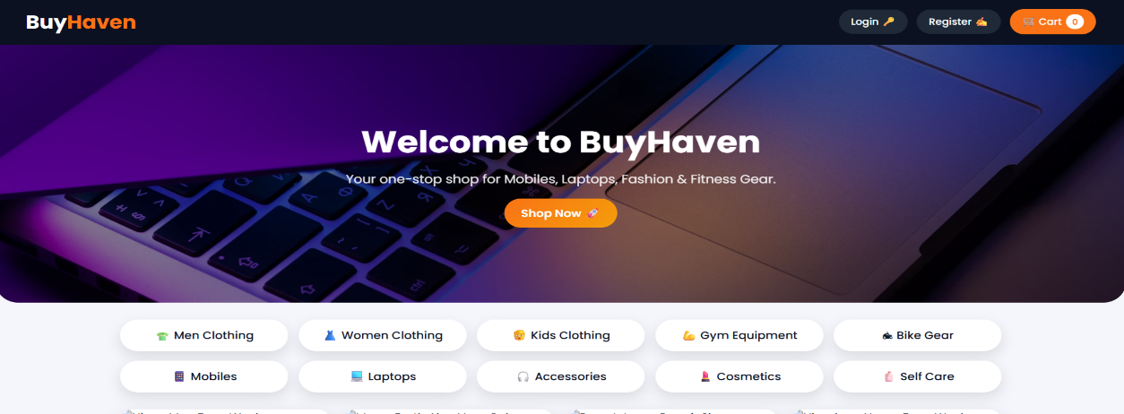
6. Session-based cart handling without login

6. Working of the System
Step 1 – Homepage & Navigation

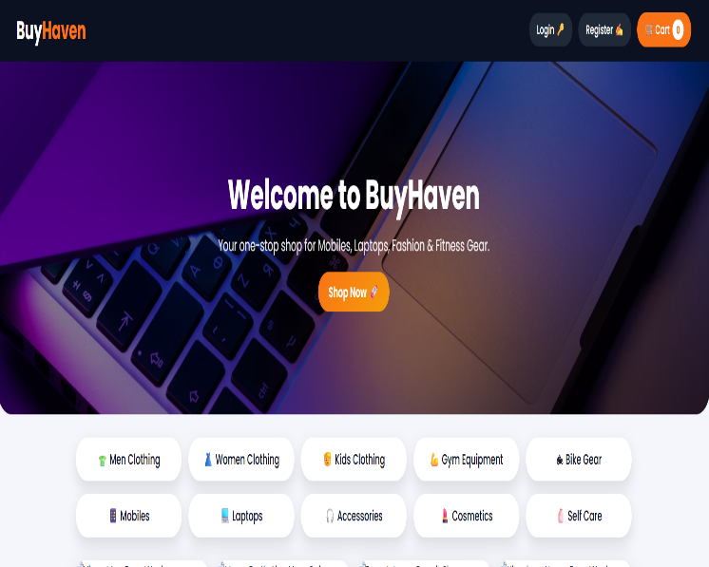
Users can explore different product categories displayed on the homepage. Each category redirects to a product listing page fetched dynamically from MySQL.

Step 2 – Viewing Products
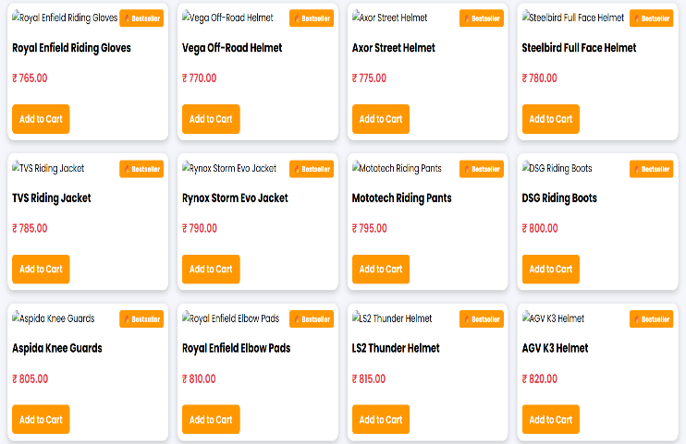
Products are displayed with details such as:
1. Product Name, 2.Price, 3.Add to Cart Button

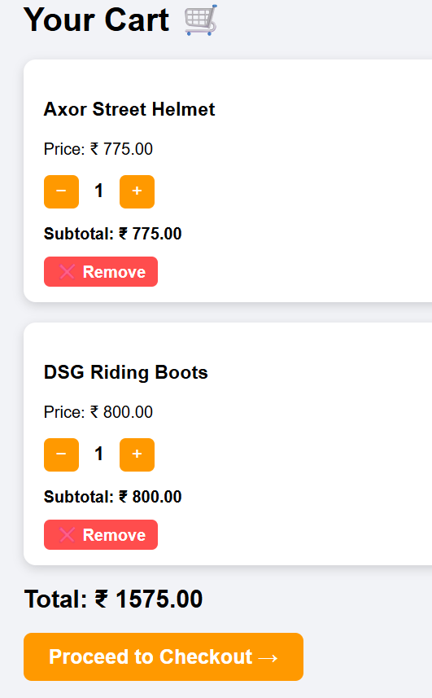
Step 3 – Cart Management

Users can:

1.Add items to cart, 2.View items in cart ,3.Increase/Decrease quantity. 4.Remove items completely

All cart operations update dynamically without refreshing the entire page.

Step 4 – Database Interaction
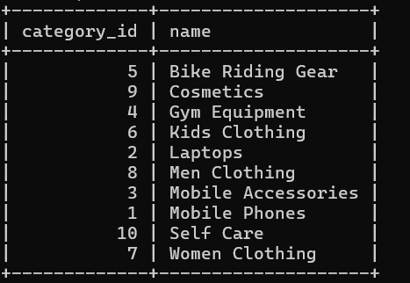

MySQL stores all product details in normalized tables. Flask interacts with MySQL using SQL queries to fetch category-wise products.

7. Database Schema
Tables Used
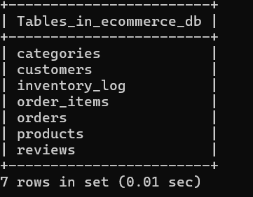
categories – Stores category ID and category name

products – Stores product details mapped with categories

users (optional) – Future scope for login system

Each product contains the following fields:
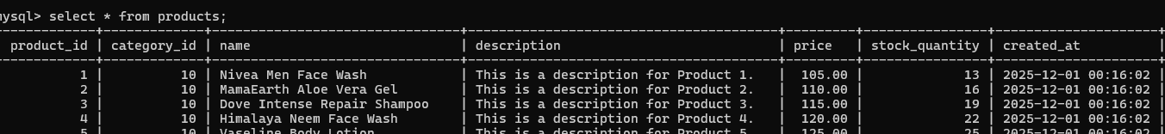

product_id, name. price . category_id

8. Output Screens

The following screens were implemented:
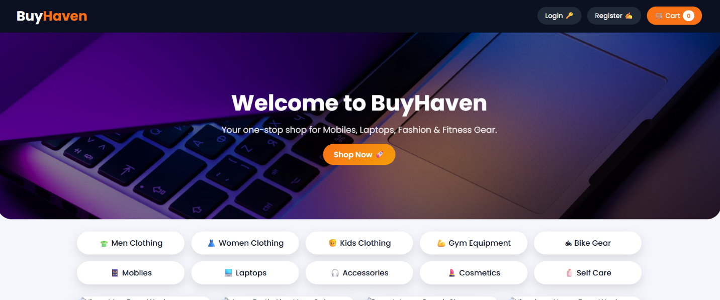

Homepage with categories
Product listing page

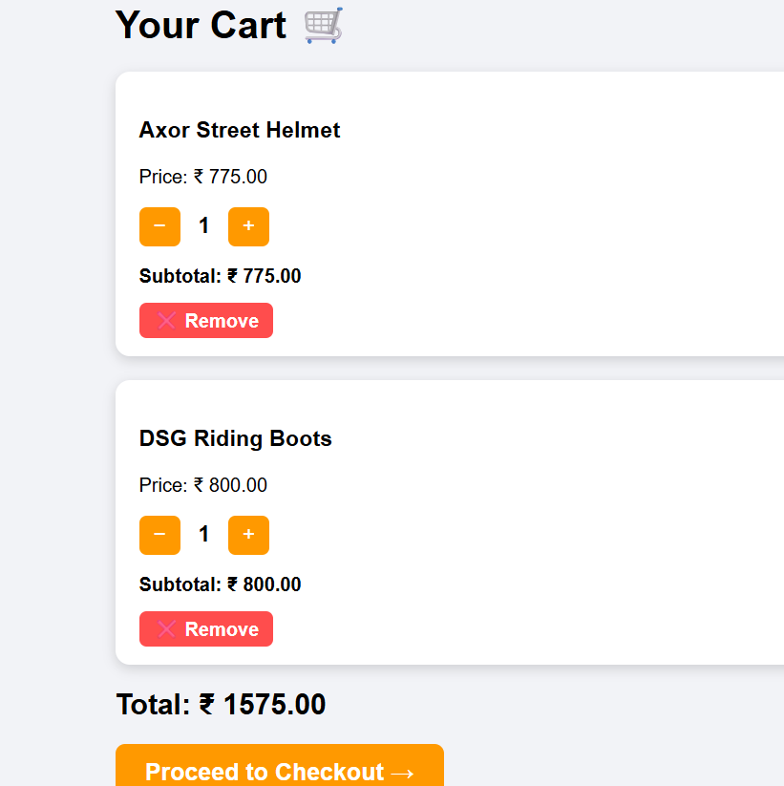

Cart page with quantity controls

9. Conclusion

The BuyHaven E-Commerce Website successfully demonstrates how a modern online store operates using Flask and MySQL. This project helped me understand:

Backend logic using Python Flask

Handling dynamic content and sessions

Database relationships and SQL operations

Web application deployment via Ngrok

The project fulfills all stated objectives and can be extended further with features like user login, payment gateway integration, order tracking, and product recommendations.

10. Future Enhancements

🔹 User authentication & profile management
🔹 Online payment integration (UPI, Razorpay, PayPal)
🔹 Admin dashboard for product management
🔹 Product reviews and ratings
🔹 Recommendation system using Machine Learning

